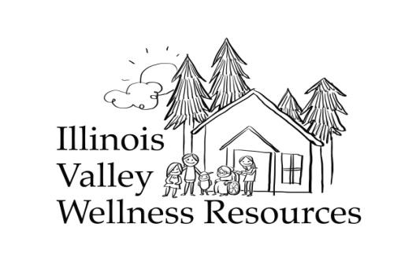

Weather Assistance Program
Qualifications: The weather assistance program is for low-income, older adults or disabled residents in the Illinois Valley. Any information provided in this application is collected to identify qualifying factors and needs. Your personal information will be kept within Illinois Valley Wellness Resources and Josephine County Public Health Department. **Return to 315 Caves Hwy. Suite C, Cave Junction, OR, 97523 or email ivwellnessresources@gmail.com or call or text 541-592-9181 for appointments.

Name:________________________________________________________________________
Home (physical) address:_________________________________________________________
Best way to contact? Call Text Email
Phone and email:______________________________________________________________
Who referred you to this program?___________
Description of weather assistance needs? ___________________________________________
_____________________________________________________________________________
How many people live in your household?__________

Household monthly income__________ Please have a letter from SSI, SNAP or OHP/Allcare Health or other to verify your income. Staff: Date and Initial verification_______________

__VA
__SNAP/Oregon Trail
__Medicaid/OHP/Allcare
__Medicare
__ SSDI
__SSI

Please sign your name to certify that all information is true to the best of your knowledge and agree to the following waiver: I will waive, discharge and agree not to hold Illinois Valley
Wellness Resources responsible for any injuries or illnesses that may occur while participating in the Weather Assistance Program.

Signature: ___________________________________________________ Date:______________

