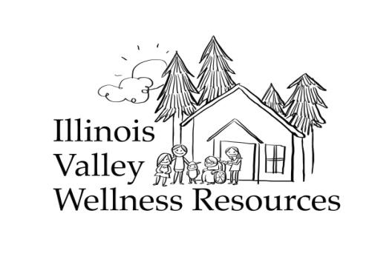

Free Air Purifier Application
Privacy statement: Air purifiers are distributed on a need based system. Any information provided in this application is collected to identify the highest need. Your personal information will be kept within Illinois Valley Wellness Resources and Oregon Health Authority. **Return to ivwellnessresources@gmail.com or call or text 541-592-9781.88
One application per household. For addresses with multiple dwellings, please fill out additional applications.

Name: _______________________________________________________________________________
Home Address:_________________________________________________________________________
Best way to contact? Call Text Email Who referred you to this program?_______________
Phone or email:____________________________________________________________________
Are you able to pick up your air purifier in/near Cave Junction? Yes No
What is your age? ________________How many other people live in your house put # by age group.

Ages 0-9 _______
10-17 _______
18-54 _______
54-64 _______
65+ _______

Household monthly income__________ Does anyone in the home use the following?

__WIC
__SNAP
__Medicaid/OHP
__Medicare
__ SSI
__ SSDI

Does anyone in the home have a health or living condition that may benefit from an air purifier?

__COPD
__Asthma w/ Rx
__Infant in the home

__Lung disease
__Use oxygen at home
__Heart Disease
__Sleep apnea with CPAP
__Emphysema
__Other: _____________

Have you used an air purifier before? ________Do you need help setting it up in your home?_________

Please sign your name to certify that all information is true to the best of your knowledge:
Signature: ___________________________________________________ Date:______________

